Data analytics for banking coursework
✅ | Mandatory/done in class
*️⃣ | On the chopping block
☑️ | Possibly
❌ | NO

Companies
Company name | Ticker | Bloomberg ticker | Primary exchange | BICS sector 4 level
Siemens AG | SIE.DE | SIE GY Equity | Xetra | Diversified Industrials
First solar | FSLR | FSLR US Equity | NASDAQ GS | Renewable Energy Equipment
Eni SpA | ENI.MI | ENI IM Equity | Borsa Italiana | Integrated Oils
EnerSys | ENS | ENS US Equity | New York | Renewable Energy Equipment
Shell PLC | SHEL.L | SHEL LN Equity | London | Integrated Oils
Snam S.p.A. | SRG.MI | SRG IM Equity | Borsa Italiana | Gas Utilities
Ultralife Corporation | ULBI | ULBI US Equity | NASDAQ GM | Renewable Energy Equipment
TotalEnergies SE | TTE | TTE FP Equity | EN Paris | Integrated Oils
Ameresco Inc. | AMRC | AMRC US equity | New York | Renewable Energy Project Dev
NextEra Energy, Inc. | NEE | NEE US Equity | New York | Integrated Electric Utilities
Sunex S.A. | HN6.F | SNX PW Equity | Warsaw | Renewable Energy Equipment

Work

Prices/Returns
✅Statistical measures describe function
Cross table to see independence through monthly / cross table
✅Market $β$ Reference index
☑️Cointegration to see if these green energy companies simulate a green index (shell idk)
*️⃣Correlation vs cointegration matrix Heatmap / table
✅VAR for both 1% and 5% based on historical values

Graphs
✅Price line chart (maybe one per company/ faceted)
✅Boxplot / violin plot /
*️⃣QQ-plot of returns
✅Correlation matrix of returns heatmap
✅Rolling volatility / moving average chart

RATIOS
Grouped bar for all variables (trends?)
✅Scatter plots
X | Y
MKTCAP | PE | *️⃣
MKTCAP | EPS | *️⃣
ESG | ROA/ROE | ❌
ESG | PE | ❌
ESG | EPS | ❌
PE | EPS | *️⃣

ROE-ROA to see how much of the returns come from debt

PANEL DATA??
❌Price on a quarterly basis??? If so panel data to see from a regression impact how the variables impact (Stargazer/gt)

Company official description from Bloomberg (Ankit)
- Siemens AG is an engineering and manufacturing company. The Company focuses on areas of electrification, automation, and digitalization. Siemens also provides engineering solutions in automation and control, power, transportation, and medical diagnosis.
- First Solar, Inc. designs and manufactures solar modules. The Company uses a thin film semiconductor technology to manufacture electricity-producing solar modules.
- Eni SpA explores for and produces hydrocarbons in Italy, Africa, the North Sea, the Gulf of Mexico, Kazakhstan, and Australia. The Company both produces natural gas and imports it for sale in Italy and elsewhere in Europe. Eni transports natural gas in pipelines. The Company generates and trades electricity, refines oil, and operates gasoline service stations.
- EnerSys manufactures, markets, and distributes industrial batteries. The Company also manufactures, markets, and distributes related products such as chargers, power equipment, and battery accessories. EnerSys provides related after-market and customer-support services for lead-acid industrial batteries.
- Shell PLC explores and refines petroleum products. The Company produces and imports fuels, chemicals, and lubricants, as well as operates service station networks. Shell serves clients worldwide.
- Snam S.p.A. owns and operates Italy's natural-gas distribution network. The Company transports gas on behalf of importers, distributors, and companies supplying Italian households. Snam owns a network of high-and medium-pressure pipes, including trunk lines connected to production and importation sites in Italy.
- Ultralife Corporation is a battery, energy and communication product company that serves government, defense and commercial customers. The Company's energy services provide back-up/stationary power services and solutions to the communications, power utility and data processing industries. The battery and energy product segment provides non-rechargeable and rechargeable batteries.
- TotalEnergies SE operates as an energy company. The Company produces, transports, and supplies crude oil, natural gas, and low carbon electricity, as well as refining petrochemical products. TotalEnergies owns and manages gasoline filling stations worldwide.
- Ameresco Inc. is an integrated electric energy corporation. The Company supplies a range of energy solutions, including energy cogeneration, hydroelectric, and renewable energy facilities.
- Sunex S.A. manufactures solar technology solutions. The Company offers flat solar collectors, fixing systems, solar heaters, heat exchanging stations, and solar equipment.

source("C:\\Users\\pietr\\OneDrive - City St George's, University of London\\Desktop\\formula.main.R")
port <- get_portfolio(c("PBW", "XOP", "SIE.DE", "FSLR", "ENI.MI", "ENS", "SHEL.L", "SRG.MI", "ULBI", "TTE", "AMRC", "NEE"),
start_date = "2019-01-01", clean_names = T)

is.na(port) %>% apply(2, sum)

quickplot(port)
port <- na.approx(port)
apply(port,2, ROC, type = "cont") %>% cor(use = "complete.obs") %>% ggcorrplot(lab = T)

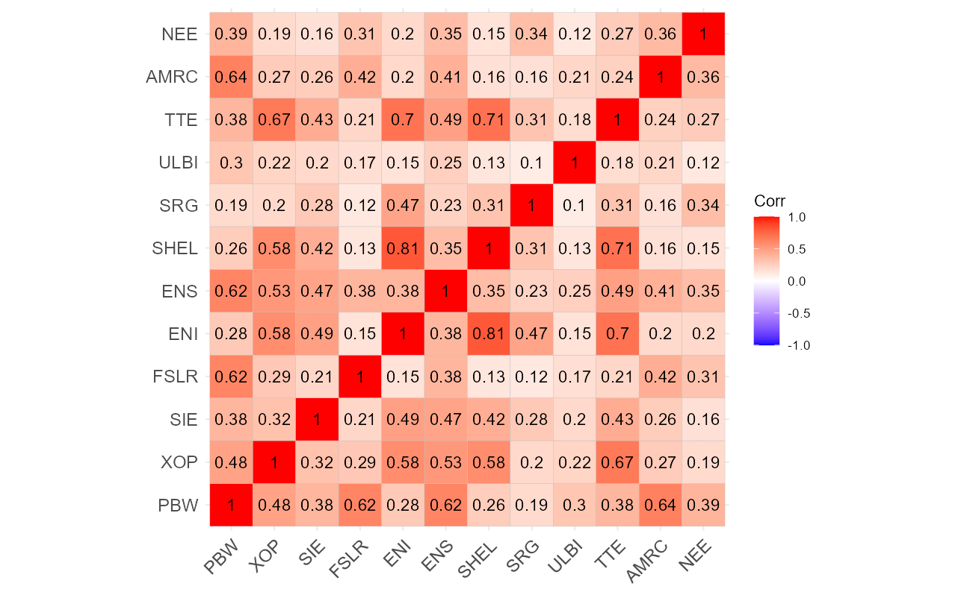
Invesco WilderHill Clean Energy ETF Stocks from companies focusing on clean energy and conservation.Another popular choice for tracking a broad portfolio of U.S. and global clean energy companies.
SPDR S&P Oil & Gas Exploration & Production ETF Tracks companies focused primarily on exploration and production (E&P) of oil and gas.Highly correlated with the actual commodity prices (Crude Oil and Natural Gas). If oil prices soar, these stocks usually soar faster than the integrated majors.

